# Setup Repository for Github and Sourcetree

## Create repository in local

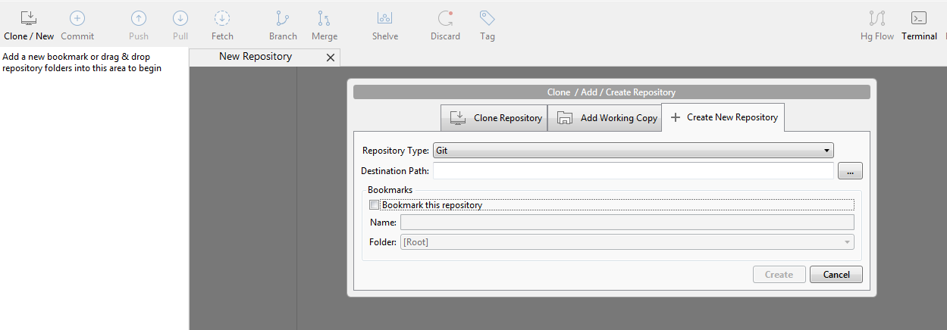

Create Repository in local

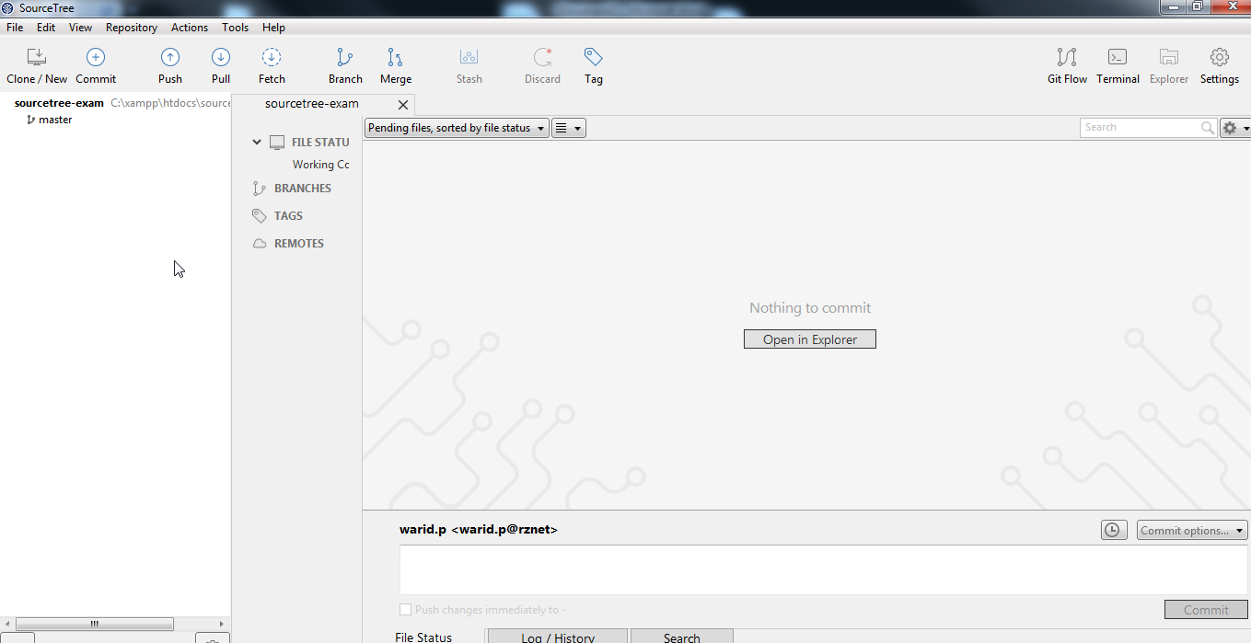

Menu description

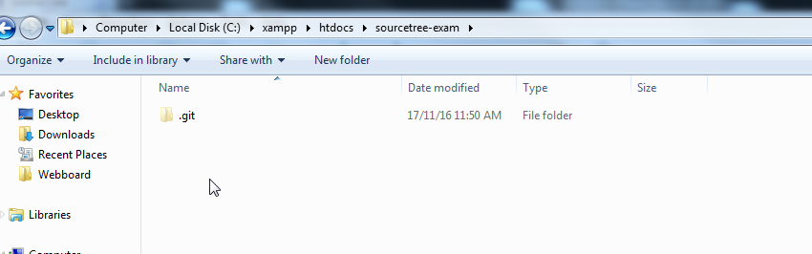

Blank folder get tracked

## Create new repository on Github

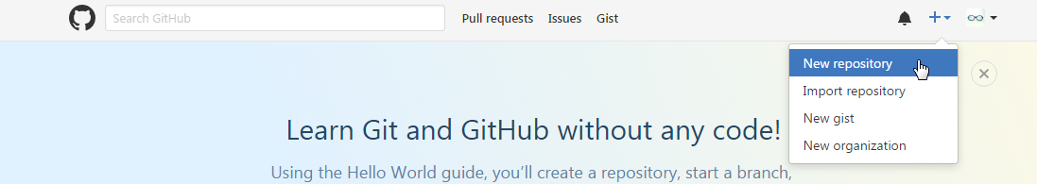

Login to github

Create new repository on github

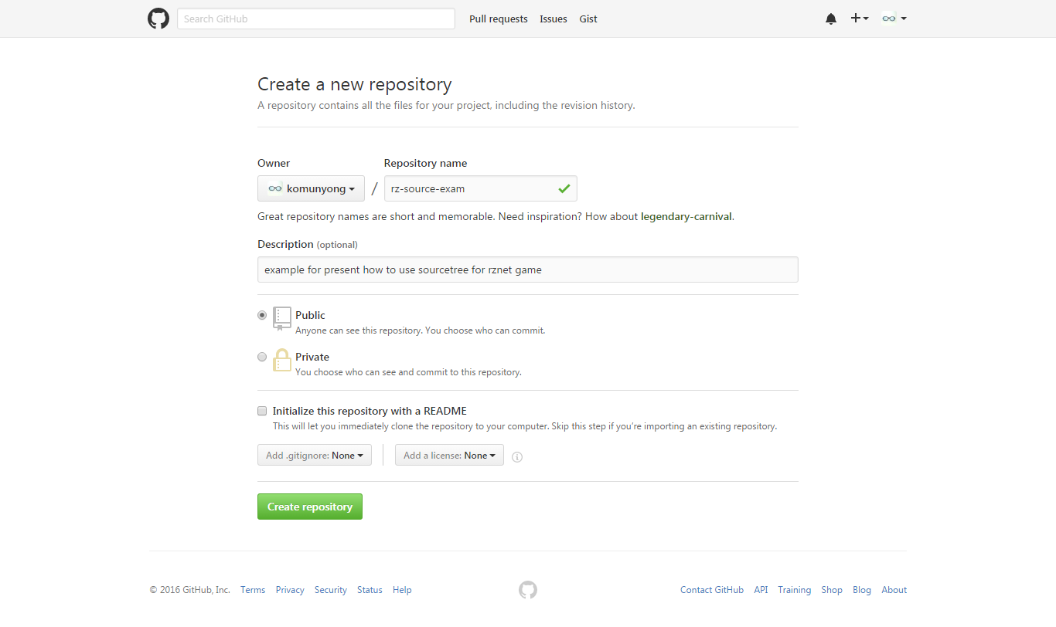

Create repository on github

*notice : paid account for private repository

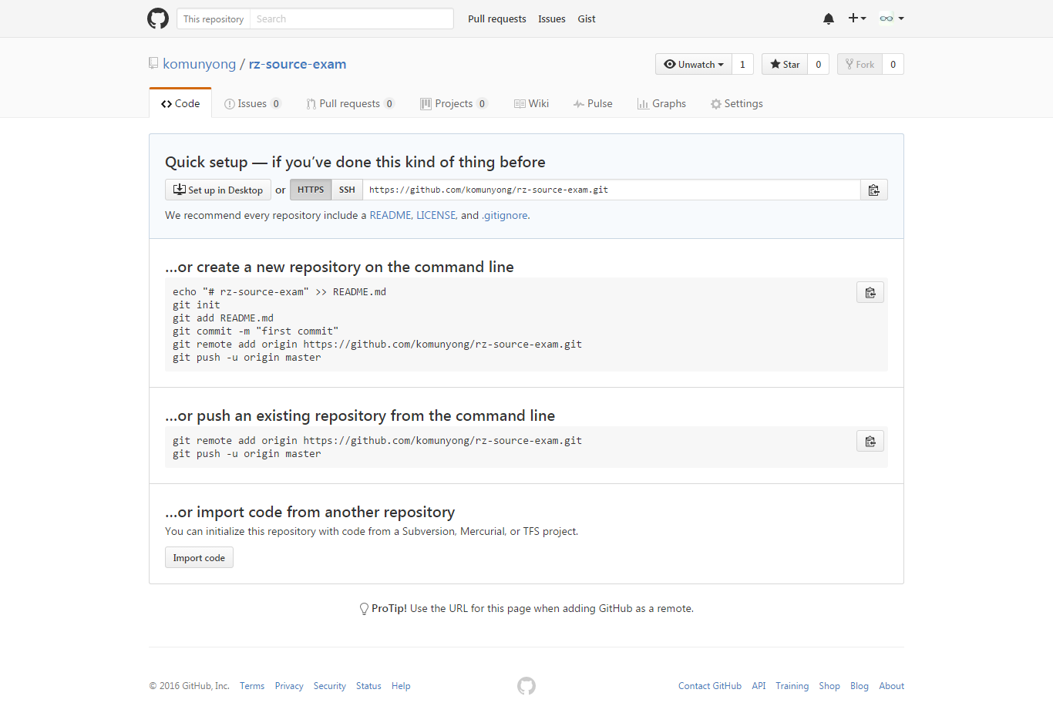

Project on github after create

## Add remote from Github to Sourcetree

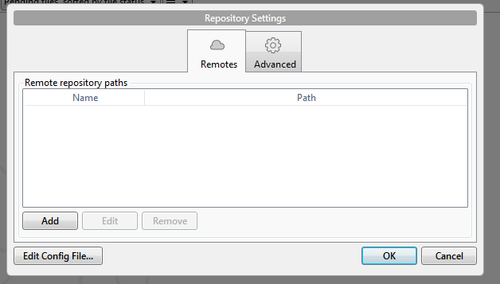

Link remote on github to local

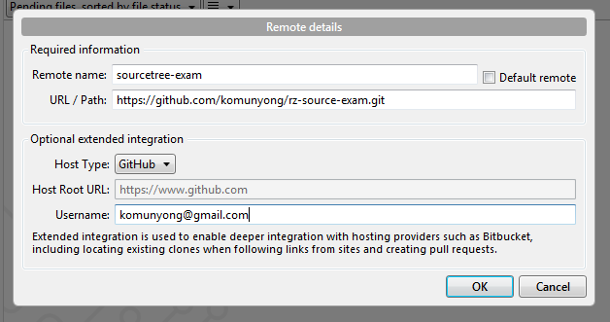

Detail for add remote on github

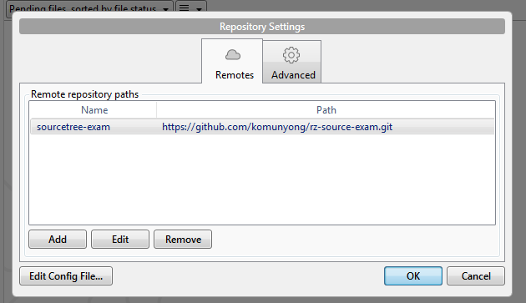

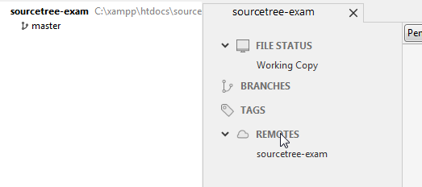

Screen in sourcetree after add remote on github

# Manage repository version

## Add (Stage) new file to Github

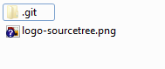

Copy some image file to your folder

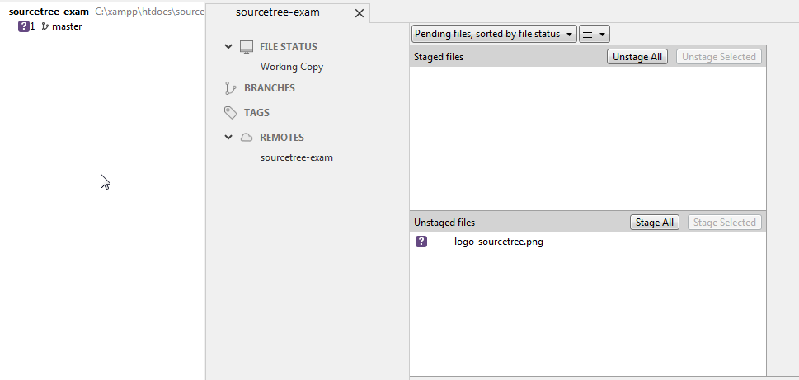

New file that not staged (shown in question mark)

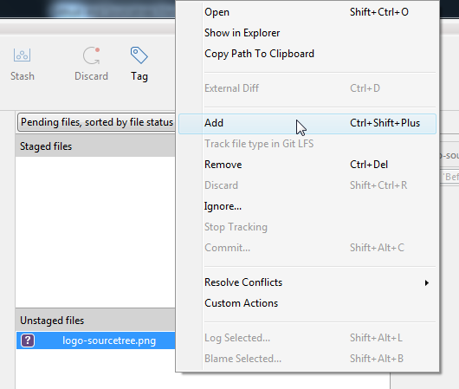

Choose Add (Ctrl+Shift+Plus) to start track new file

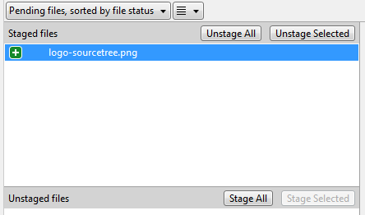

After add new file

See : Commit

See : Push

## Commit stage file in local

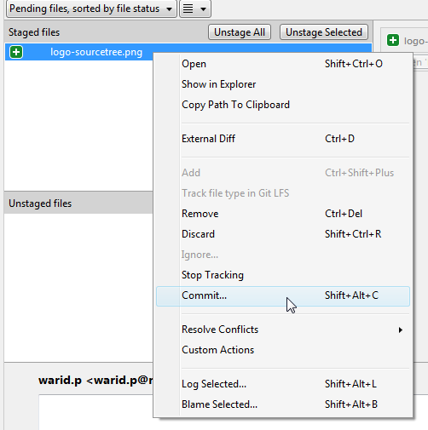

How to commit

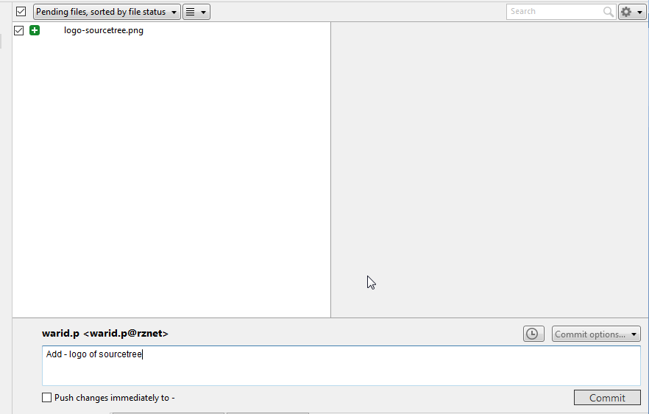

Commit screen

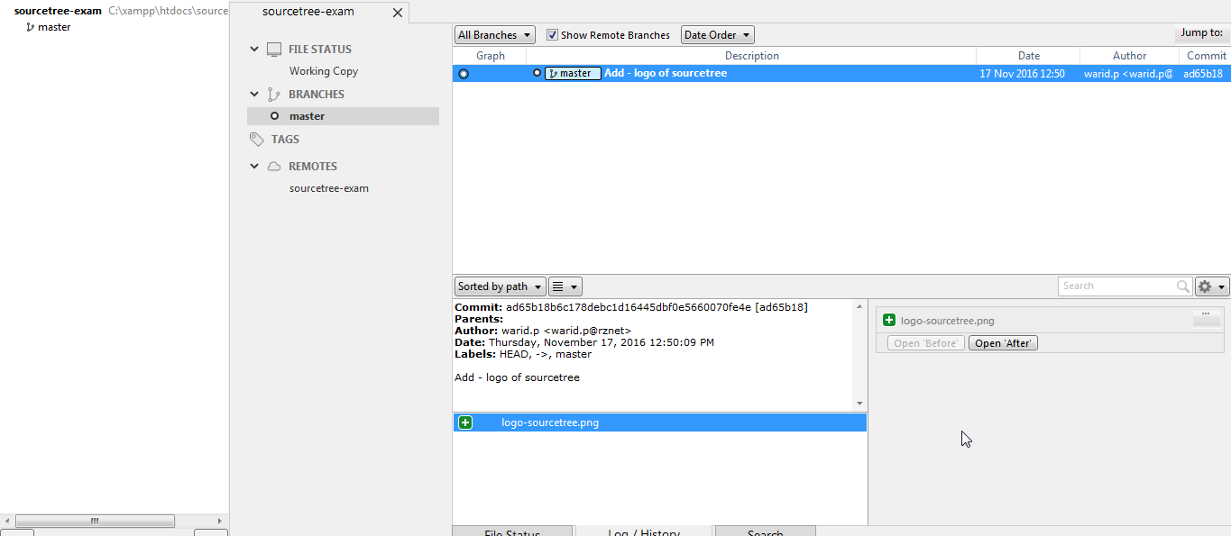

After commit in version log/history

## Push file to Github

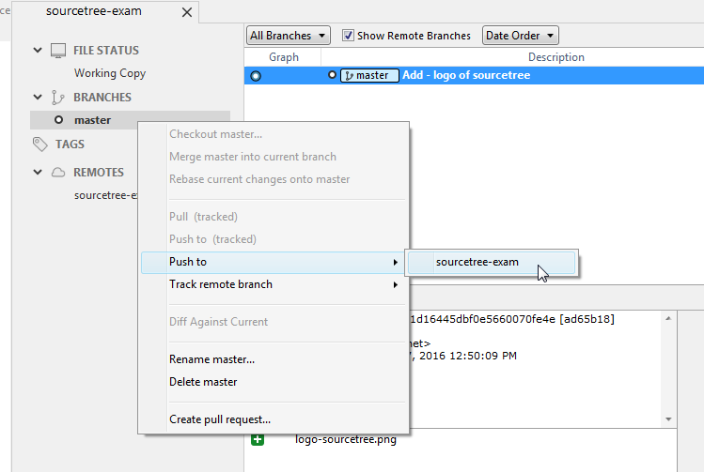

Push to repository on Github

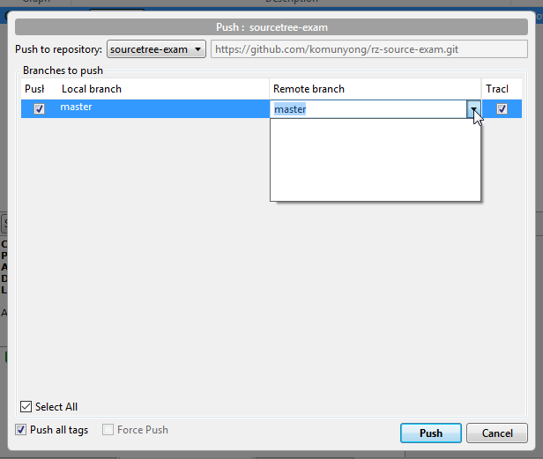

Choose remote branch that you need to push > click push

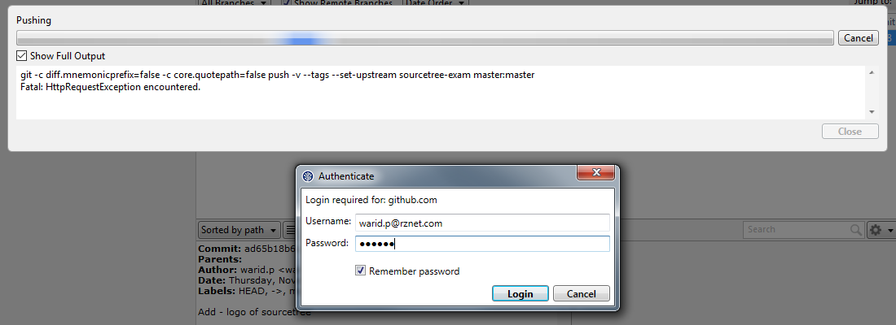

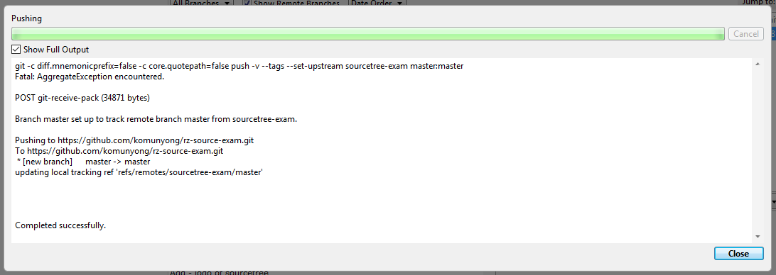

After push success message

After push on Github repository

*notice : in case that have credential on window, it required window authenticate first and then Github authenticate

## Pull from Github

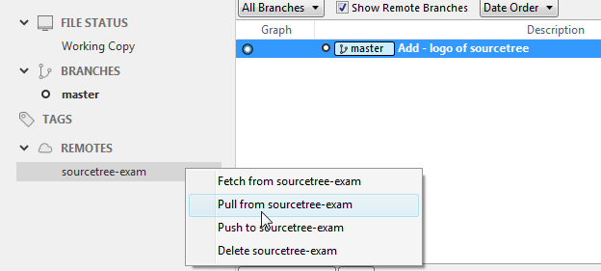

Pull interface

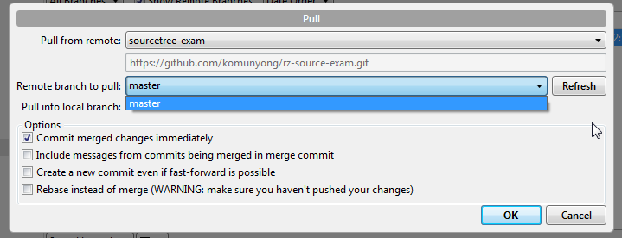

Choose remote branch before pull

## Add team member to Github team

## 

Go to collaborator to add new person to group

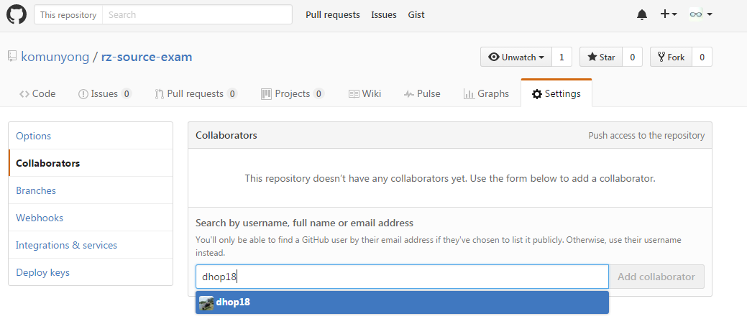

## 

Waiting for accept (by email)

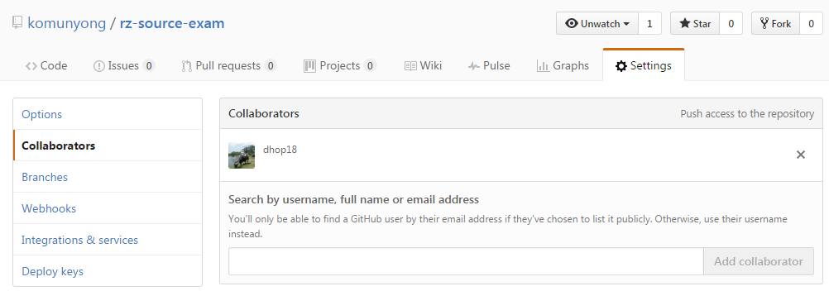

After accept

# Problem

## Forget to install Git (Download Here : <https://git-scm.com/downloads> )

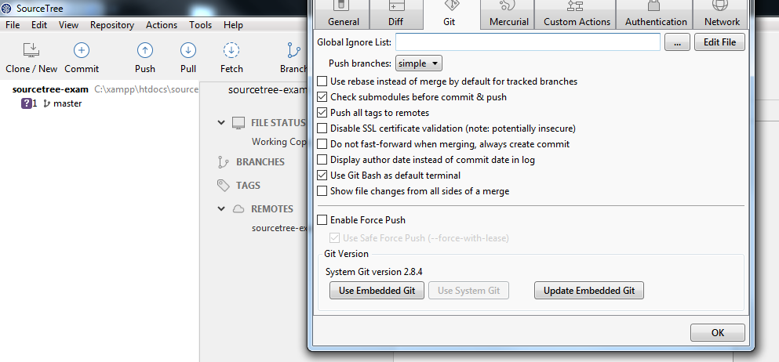

Setting Tools > Git > Git Version > Use System Git

If doesn’t work, check on git.exe in your computer or go to command line and type git -v

Push with wrong email password

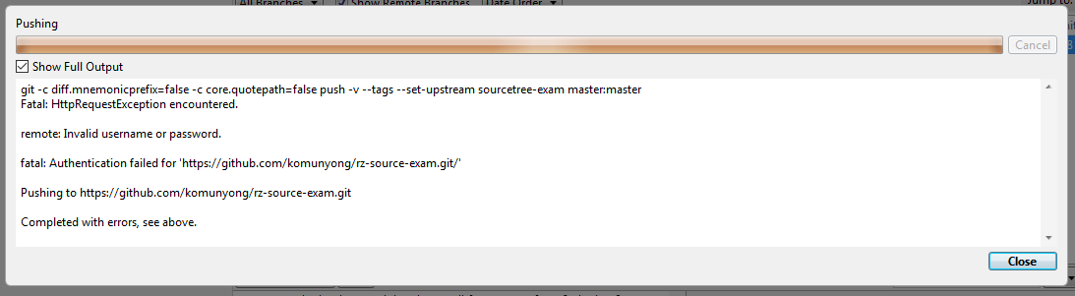

Required Github username and password